Cloud Computing (Practical 2)

Aim:
To deploy a simple web application using Google App Engine on Google Cloud Platform.

Objectives:
- To understand Google Cloud Platform (GCP) environment
- To learn how to use Cloud Shell
- To create and configure a simple web application
- To deploy the application using App Engine
- To access the deployed application via a web URL

Prerequisites:
- Google Cloud account
- Internet connection
- Basic knowledge of HTML
- Basic knowledge of Linux commands

Theory:

Introduction to Cloud Computing
Cloud computing is a modern technology that provides computing resources such as servers, storage, databases, networking, and software over the internet. Instead of maintaining physical hardware or local servers, users can access these resources remotely from anywhere using an internet connection.
Cloud computing eliminates the need for heavy infrastructure management and allows users to focus on application development and deployment. It is widely used in industries for hosting applications, storing data, running analytics, and delivering services efficiently.

Key Features of Cloud Computing:
- On-demand self-service: Resources can be accessed whenever required without human interaction
- Scalability: Resources can be increased or decreased based on demand
- Cost-effective: Users pay only for the resources they use (pay-as-you-go model)
- High availability: Services are available almost all the time with minimal downtime
- Resource pooling: Multiple users share resources securely

Google Cloud Platform (GCP)
Google Cloud Platform is a cloud service provider offered by Google that provides a wide range of services including computing, storage, networking, databases, and artificial intelligence.
GCP allows developers to build, test, and deploy applications without worrying about underlying infrastructure. It provides a highly secure and scalable environment.
Services used in this experiment:
- Google Cloud Console: A web-based interface to manage cloud resources
- Cloud Shell: A browser-based Linux terminal with pre-installed tools
- App Engine: A platform to deploy and host web applications

Cloud Shell
Cloud Shell is an interactive command-line interface provided by Google Cloud. It is accessible directly from the browser and does not require any local installation.
Advantages:
- Pre-configured with essential tools like gcloud
- Accessible from anywhere
- Provides a temporary virtual machine
- Supports Linux commands
Cloud Shell is used in this experiment to create files, configure the application, and deploy it.
Web Application

A web application is a program that runs on a web server and is accessed through a web browser. It consists of frontend components (HTML, CSS) and backend services.

Working of a Web Application:
- User enters a URL in the browser
- Browser sends a request to the server
- Server processes the request
- Server sends back a response (webpage)
- Browser displays the content

Google App Engine
Google App Engine is a Platform as a Service (PaaS) offered by GCP that allows developers to deploy applications without managing servers.
It automatically handles:
- Scaling
- Load balancing
- Server management
Features:
- Fully managed platform
- Automatic scaling
- High reliability
- Supports multiple programming languages
In this experiment, App Engine is used to deploy a simple HTML webpage.

Application Configuration (app.yaml)
The app.yaml file is a configuration file required by App Engine. It defines how the application should run.
Key Components:
- runtime: Specifies the programming environment (e.g., python311)
- handlers: Defines how requests are handled
This file tells App Engine how to serve the web application.

HTML Webpage
HTML (HyperText Markup Language) is used to create web pages.
Basic structure:
- <html> → Root element
- <head> → Contains title
- <body> → Contains content
In this experiment, a simple webpage is created with:
- Heading
- Name
- Experiment title

Deployment Process
Deployment is the process of uploading and hosting the application on a cloud platform so that it can be accessed via the internet.
Steps involved:
- Creating project
- Writing application files
- Configuring app.yaml
- Deploying using gcloud app deploy
After deployment, the application is assigned a unique URL.

Testing the Server
After deployment, the application is tested using:
- gcloud app browse
This command opens the deployed application in a browser.
Purpose:
- Verify application is running
- Check output correctness
- Ensure successful deployment

Implementation / Procedure:

Step 1: Create a New Project
- Open Google Cloud Console
- Click on Project Selector → New Project
- Enter project name (e.g., RaghavendraDeshpandePrac2)
- Click Create
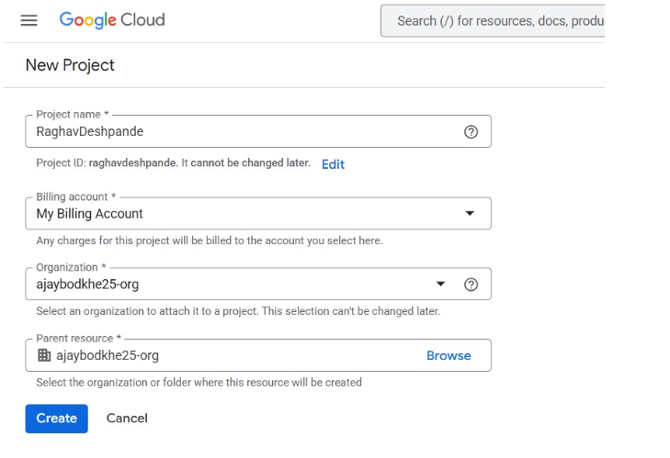

Step 2: Open Cloud Shell
- Click on Activate Cloud Shell icon
- Terminal will open at bottom
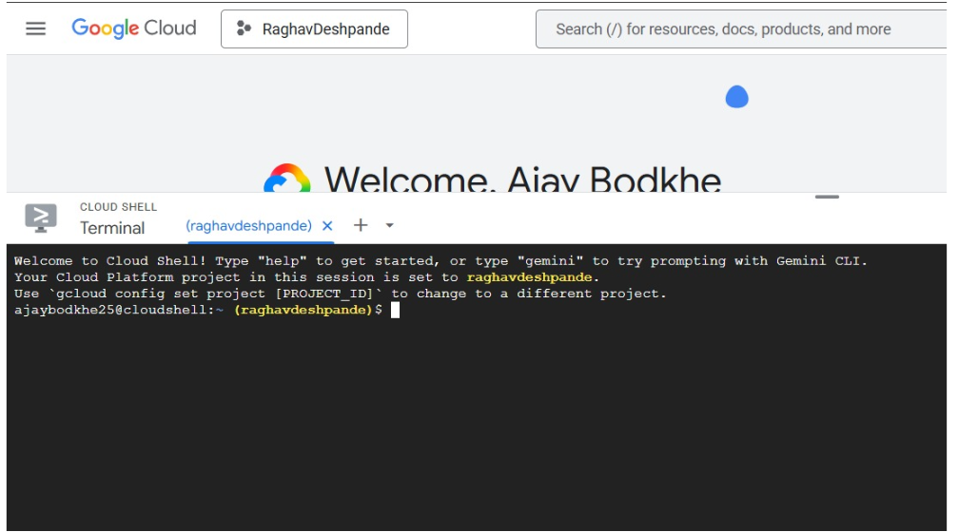

Step 3: Create Application Folder
- mkdir myapp
- cd myapp
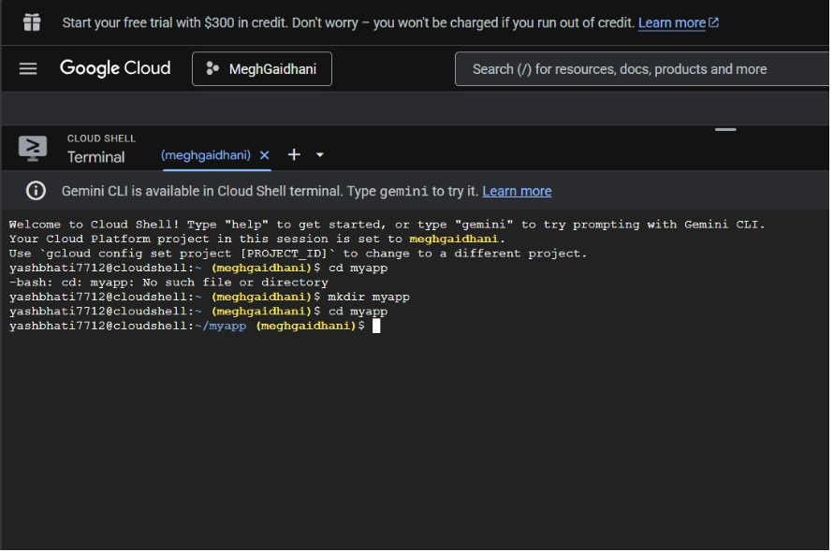

Step 4: Create HTML File
- nano index.html
Add:
<html>
<head>
<title>My First App Engine Page</title>
</head>
<body>
<h1>Hello from Google App Engine</h1>
<h2>Name: Megh</h2>
<h3>Experiment 2 Completed</h3>
</body>
</html>
Save and exit.
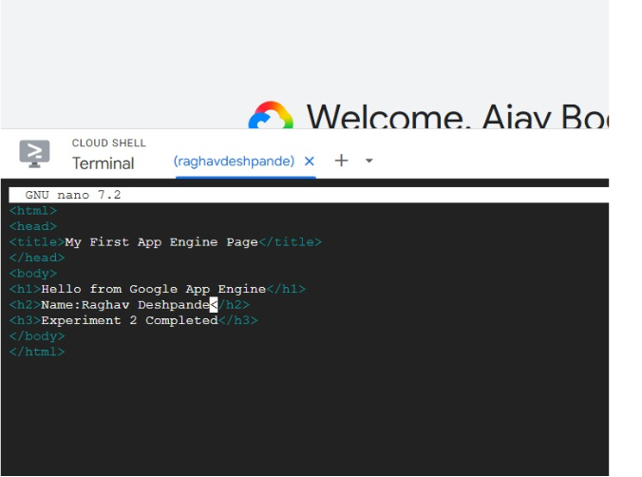

Step 5: Create app.yaml File
- nano app.yaml
Add:
runtime: python311

handlers:
- url: /
static_files: index.html
upload: index.html

- url: /(.*)
static_files: \1
upload: (.*)
Save and exit.
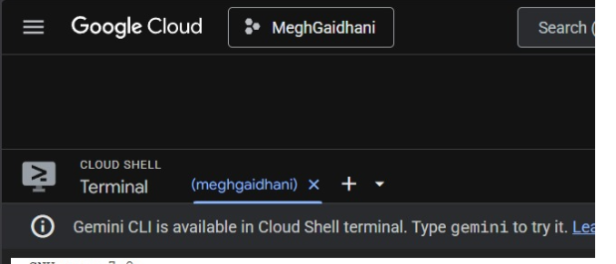
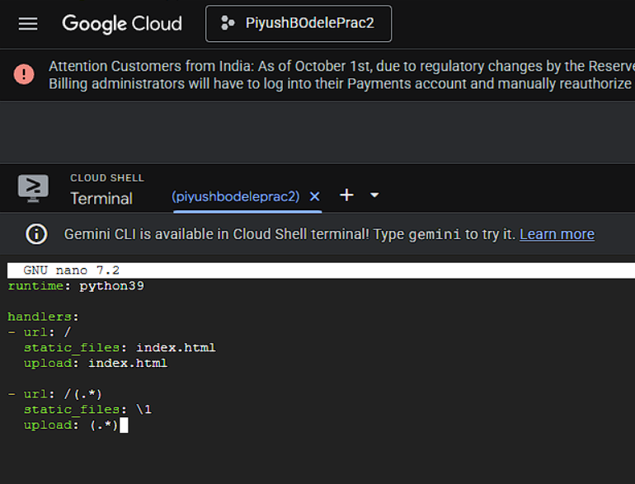

Step 6: Initialize App Engine
- gcloud app create
Select region (e.g., asia-southeast1)
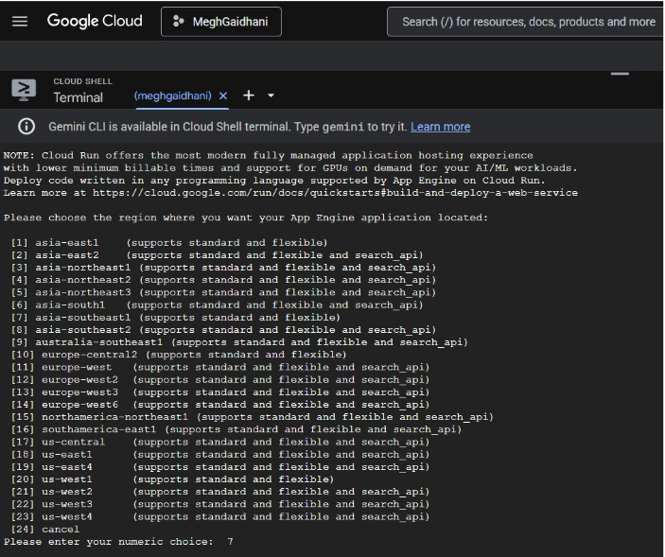

Step 7: Deploy Application
- gcloud app deploy
Type Y to continue
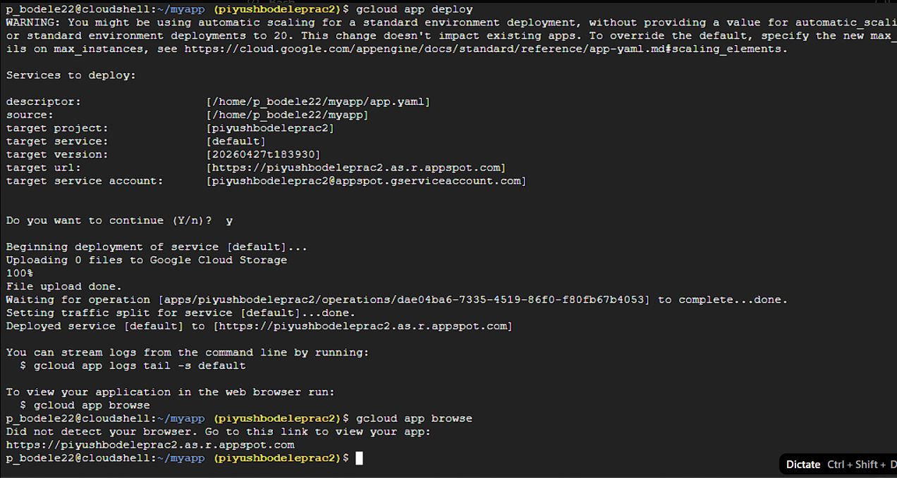

Step 8: Open Deployed Application
- gcloud app browse
OR open URL shown in terminal
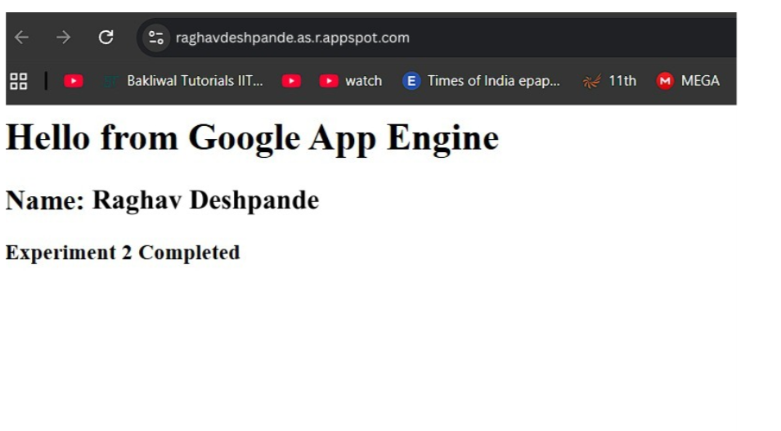

Conclusion:
In this experiment, we successfully learned how to use Google Cloud Platform to deploy a web application using Google App Engine. A new project was created, and Cloud Shell was used to develop and manage the application files. A simple HTML webpage was designed and configured using the app.yaml file.
The application was deployed using the gcloud app deploy command, and the output was successfully accessed through a web browser using a generated URL. This experiment helped in understanding the basic concepts of cloud computing, deployment process, and working of a Platform as a Service (PaaS) model.
Overall, the experiment provided practical knowledge of hosting applications on the cloud without managing physical servers, highlighting the scalability, flexibility, and efficiency of cloud-based solutions.

